YUKA
Phase 3: PRODUCT REQUIREMENT DOCUMENT

Why? (Objective)

User :
Health conscious/General wellness focused users are finding YUKA scores are misleading as some products that they know that are ‘healthy’ for them are poorly scored and vice versa. This lack of contextual scoring leads to confusion and reduces trust in the app for the user

For Business:
This is a complex problem to solve as multiple factors such as concentration,real nutritional value of a product beyond nutriscores,user’s health goals have to be considered to give accurate scores that are relevant for them. Users don’t go for conversion as they are not happy with ‘basic’ scoring and use the app only for ‘additives’ checking, this affects revenue as it reduces conversion. If this is not addressed, it could gradually affect retention in future.

Who are the users ?
Health conscious,wellness focused users who are on free tier

Persona :
Susan Paul
Healthy eating and clean personal care products – focused individual, working as Occupational Therapist . A mother who uses the product regularly during weekend grocery shopping. Free tier user, for past 6 months

Needs :
- Interested in scanning food products to ensure if they are free of additives, healthy, not highly processed
- Have YUKA provide accurate scores that she can rely on for her, family’s healthy eating habits
- Use YUKA to avoid cosmetics, kids personal care products such as soaps, suncreams that includes chemicals or toxins

Problems we are solving :
Scoring feels misleading. Users feel the scoring is not accurate in some cases and does not consider their individual health preferences such as ultra processing levels, micro plastics, allergens , portion size etc . This results in scores that users find unacceptable ie some healthy products can be scored low and vice versa. Because of this they limit the app to only scan for additive, than a tool that gives them confidence in making overall healthy choice

Frustrations expressed :
- "I don’t understand why some healthy products are scored so low just because it has bit of salt."
- "I cant find how much ultra processing has gone into making of it. I would be interested in microplastics in food .I don’t know if ranking takes all of that into account"
- Sometimes scores don’t look right and additional checking of all ingredients is required

Qualitative voice of user from interview : “Sometimes the scores are off ,so I manually check the ingredients details, but only for additives .I know I am fine with slightly high calories or fats “

Survey Responses :
More than 80% of respondents have selected they personally didn’t choose to buy a product rated by YUKA as good/excellent as the product didn’t suit their health needs or contained ingredients they didn’t want and 33.9% of those felt they couldn’t explain it, but it didn’t feel right.Though YUKA never intended to score ultra processed foods as excellent, that’s how people perceive it and are actively mislead ,and they either do their own research and ignore the scores or lose confidence in the app,stop using it.

Solution
Indicate ‘Food Processing’ level as it’s a key factor that most users are concerned about when deciding if a product is healthy.
Introduce a personalised health profile through a lightweight onboarding flow that captures user’s health goals and preferences (eg: allergens, ultraprocessed foods to avoid, low fat,etc). This profile then reinterprets Yuka’s existing scoring system relative to the user’s needs. Rather than a generic score, the app interprets the score through the user’s lens. Eg: This product is ultraprocessed and has high saturated fat,based on your preferences this is to be avoided”. The solution will have a ‘What this means for you’ implemented alongside current processing score.
Non-Goals (Out of scope for this version) :
- No change to the underlying YUKA scoring algorithm — personalisation reinterprets the existing score, it does not recalculate it.
- No expanded onboarding beyond a lightweight preference flow — this is quick-capture, not a full health questionnaire.

Other Alternatives considered :

SOLUTION | REACH | IMPACT | CONF | EFFORT | RICE SCORE | NOTES
Personalised food scores with goal onboarding | 3 | 3 | 3 | 3 | 9 | Directly targets the root cause (lack of individual context); sequence after Food Processing given shared effort on profile build
Indicate Food Processing level | 3 | 3 | 3 | 2 | 13.5 | Reaches all users,higher confidence based on qualitative user feedback
Customization for individual needs | 2 | 3 | 3 | 2 | 9 | easy to build based on existing platform features,strong evidence for the need from platform analysis and user surveys but could be offered only for members
Access Health Metrics from connected devices/applications | 1 | 3 | 2 | 3 | 2 | Moonshot feature which relies on integrating with phone’s health ecosystem and targeted towards niche audience
Over Simplificaiton of scoring | 2 | 3 | 2 | 3 | 4 | Changes core scoring capability and could be idea for future
Present hazards associated with ingredients | 3 | 1 | 2 | 1 | 6 | Low impact and can make some users overwhelmed with more detailed health hazard information

Product Flow

Flow Diagram (Current Status)

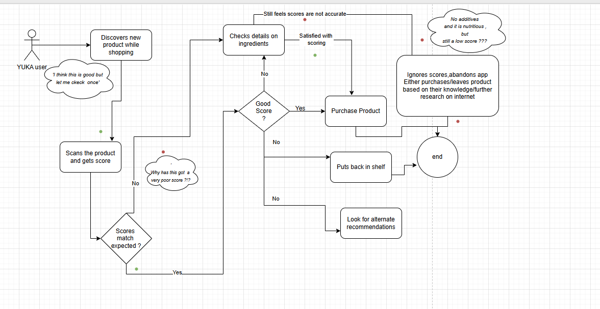

Flow Diagram (Future)

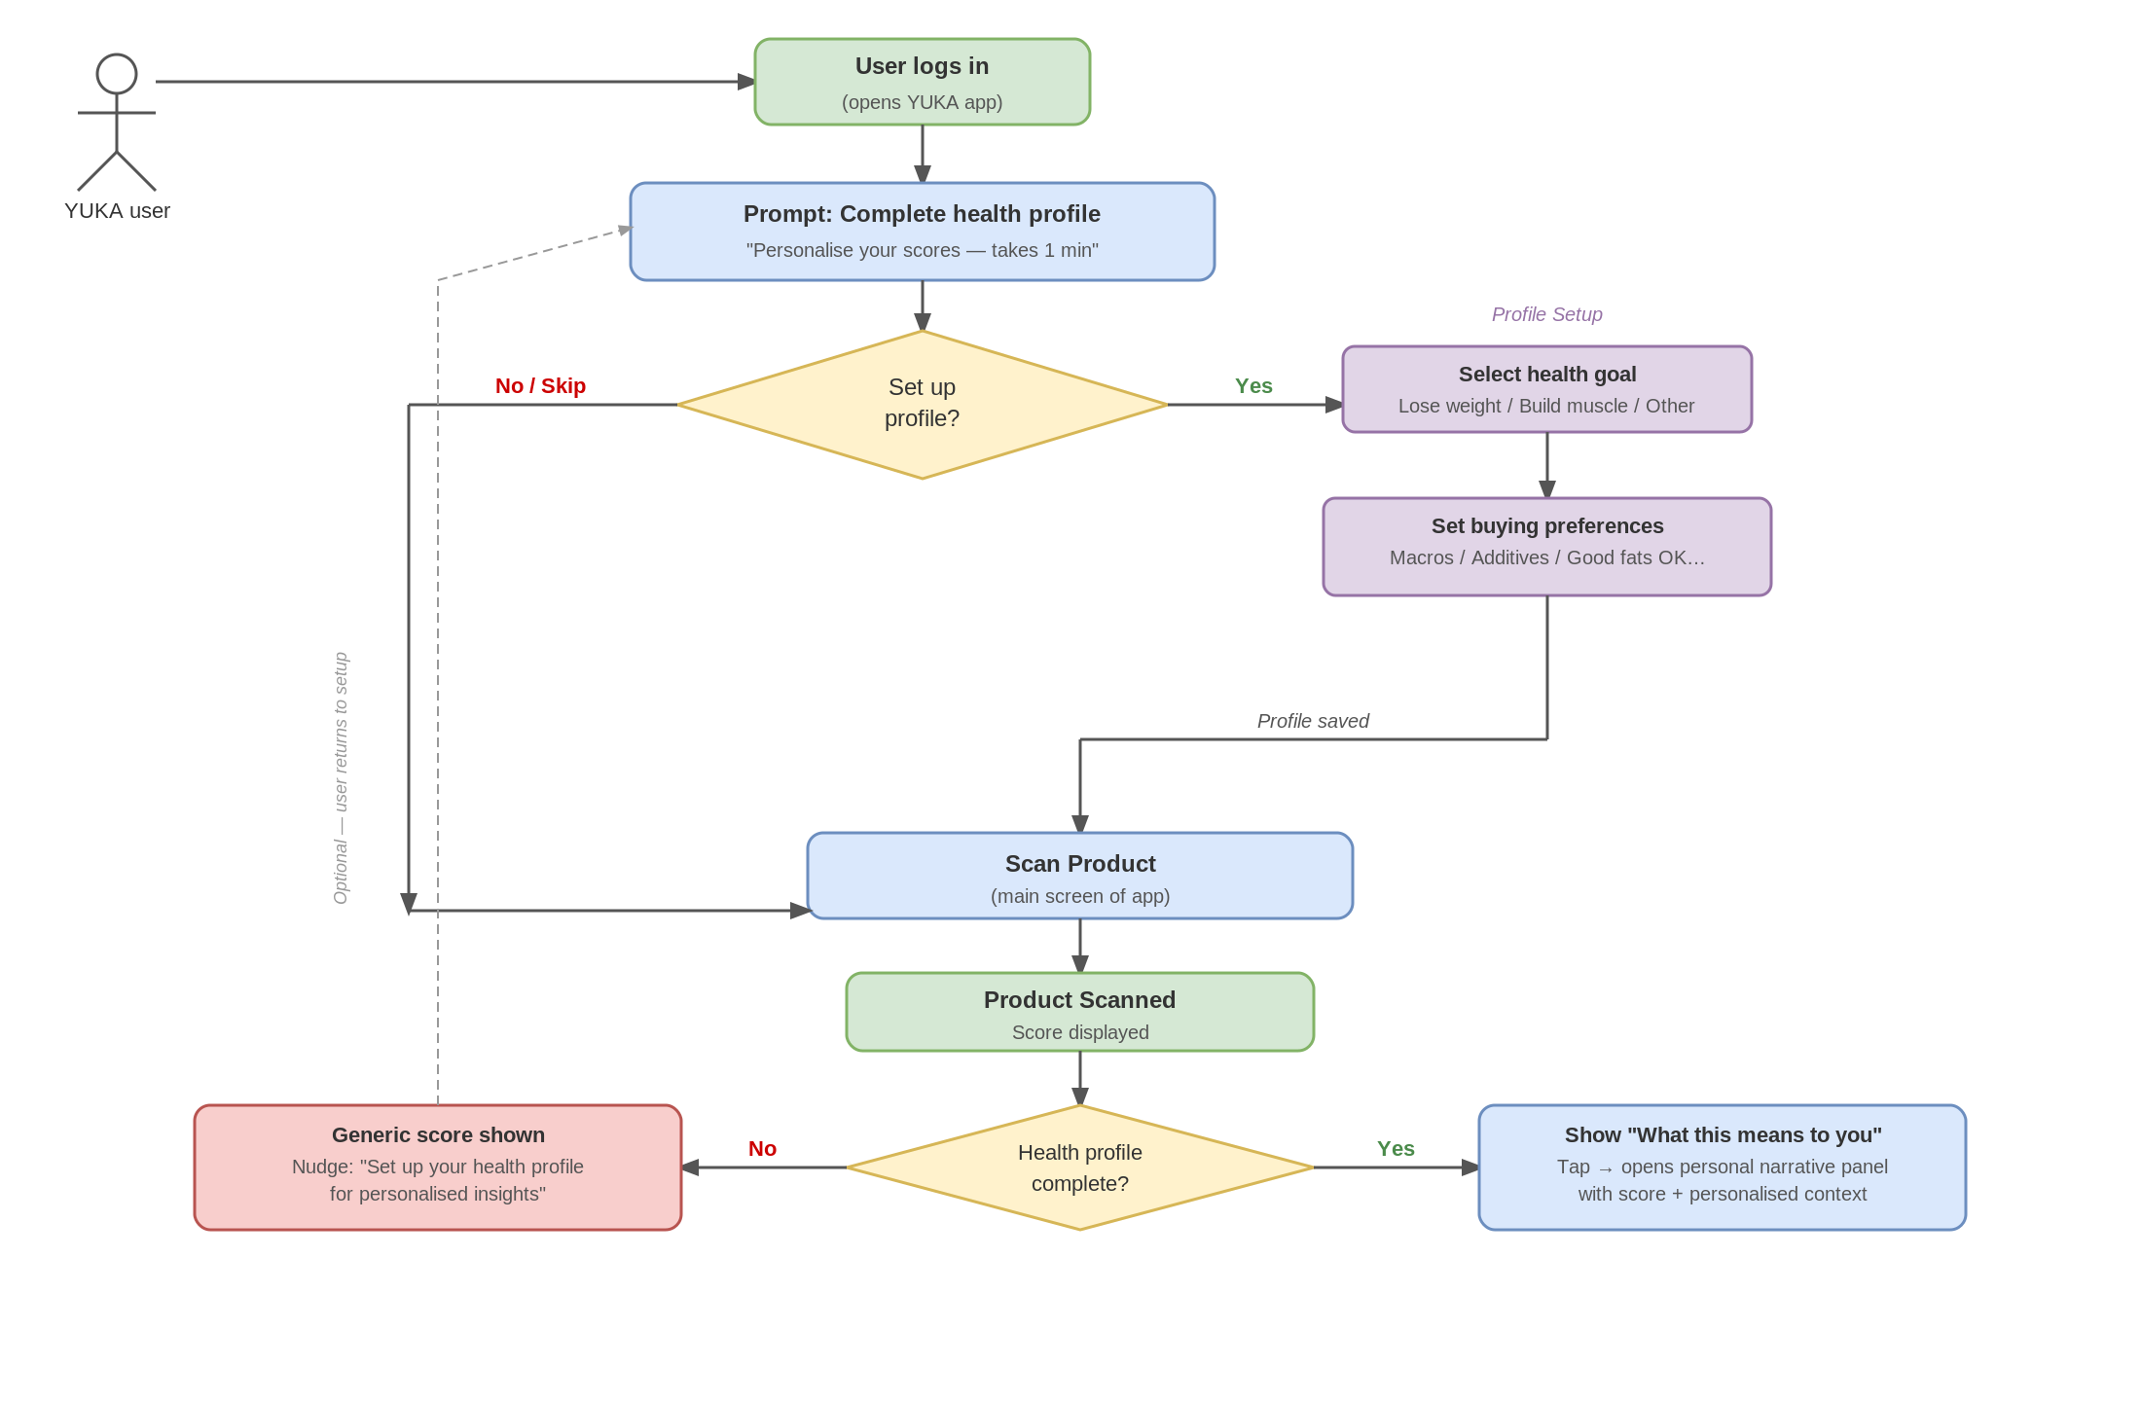

Prototype
https://ai.studio/apps/59949c46-84d6-479c-bcdc-9c97b44b3b96

High Level Features :

1.As a user
When I come across packaged food products
I want ‘Food processing’ levels displayed
So that I can better decide if the product is healthy or not based on processing levels

2.As a user
When I see scores different to my expectations
I want detailed clarification personalised to my needs
So that I can understand the rationale behind scoring and make an informed decision

Additional User Stories (Personalisation) :
3.As a user
When I set up my profile
I want to tell YUKA what I personally care about (allergens, ultra-processed avoidance, fat quality over calorie count, or anything else relevant to me)
So that future scores are interpreted in light of my actual priorities, not a generic standard

4.As a user
When I haven’t set up a profile yet
I want to see a passive prompt explaining what personalisation would look like
So that I can decide if it’s worth the few seconds of setup without being forced into it

5.As a user
When my health goals change over time
I want to easily update my profile
So that my personalised interpretation doesn’t become stale or irrelevant

6.As a user
When when I view my personalised interpretation
I want a clear takeaway (not just explanatory text)
So that I know whether a product fits my goals or not — not just why it scored the way it did

Requirements :
Must-Have (P0)
- Food Processing Level indicator displayed as a distinct, dedicated visual element on the scan result screen — Acceptance: visible without opening a secondary pane.
- Lightweight health profile onboarding capped at 3 steps, supporting open-ended preference capture (not a fixed tag list) — Acceptance: completed in ≤3 steps with user-relevant preferences captured.
- ‘What this means for you’ personalised interpretation panel shown alongside the existing score — Acceptance: reflects the user’s specific stated preferences, not a generic explanation.
- Pre-onboarding passive prompt for users without a completed profile, instead of forced onboarding.
Nice-to-Have (P1)
- Personalised verdict/signal (e.g. ‘Good for you’ / ‘Use caution’ / ‘Avoid’) shown alongside the narrative — see Open Questions.
- Periodic re-engagement nudge when a product is flagged against the user’s goals.
- Profile review prompt every 6 months or after a significant number of scans.
Future Considerations (P2)
- ‘Find a better match’ recommendation suggesting alternatives aligned to the user’s profile, gated behind membership.
- Profile-informed search/filtering across the product database.

Tentative Timelines

TASK | DATE
Leadership Approval
Design ready
Prototype Testing | 3
Development starts
Sequencing note :
Ship Food Processing Level first — it is fully RICE-scored, lower effort, and reaches all users regardless of profile completion. Personalisation follows as phase 2, once its RICE score and the blocking open questions (see Dependencies) are resolved. The ‘personalised verdict’ decision should be settled before design work on the interpretation panel begins, since it affects the UI pattern. Milestone dates above are still to be confirmed.

How do we measure success?

METRIC TYPE | METRIC NAME | DEFINITION | WHY IT MATTERS
KEY METRIC | Health Profile Completion Rate | % of new and existing users who complete the health profile onboarding after new feature launch | Measures whether users see value in personalisation from the start. Low completion indicates either friction with the process or lack of perceived value
GUARDRAIL | Profile Abandonment Rate | % of users who start but don't complete the health goal onboarding flow | High abandonment signals the onboarding is too long, complex or unclear
KEY METRIC | Personalised Score Engagement Rate | % of users who view the "what this means for you" contextual interpretation after scanning a produc | Directly measures if the personalisation feature is being used and users just stop using it after initial onboarding.
KEY METRIC | Quarterly Retention Rate | No decrease in existing free tier users over 4 quarters post-launch | Measures whether personalisation addresses the trust gap enough to keep users who were previously limiting app use to additive checking only
Supporting | Goal Preference Distribution | Breakdown of which health goals users select during onboarding (e.g. ultra-processing, allergens, low sugar) | Informs Yuka about what users care about most. If very few select ultra-processing or any other metric, this feeds back into product decisions on which goals to prioritise.
LAGGING METRIC | Free-to-Paid Conversion Rate among personalisation users | % of free-tier users who convert to paid within 90 days of completing a health profile, vs. a non-personalised control cohort | Directly ties personalisation to the conversion/business goal named in the problem statement, which was previously untracked. Note: retention metric above should be instrumented with a staggered rollout/holdout group so impact can be attributed to a specific solution rather than reported as one combined number.
METRIC | App Store Rating Improvement | Increase in average Apple app store and Google Play store rating after launch of the ‘food processing levels’ feature (tracked monthly/quarterly) | Measures overall user satisfaction and perceived feature value. Higher ratings improve app credibility, discoverability, and more user adoption
GUARDRAIL | Negative Review Rate | % of new App Store and Google Play reviews mentioning confusion or inaccurate scoring | Helps identify whether the new features are creating frustration, mistrust, or usability issues that could harm adoption and retention

Measuring Quarterly Rate of retention
No decrease in no of existing free tier users (quarterly/monthly monitor for 4 quarters)
Assumption Q1 2026 Baseline number of users (existing and already using the app) – 70 M

Quarter | Baseline | New Users
Q1 2026 | 70 M | 5 M
Q2 2026 | Target – To Retain 70M.  New Baseline – 75M | 2 M
Q3 2026 | Target – To Retain 75M.  New Baseline – 77M | 1 M
Q4 2026 | Target – To Retain 77M.  New Baseline – 78M | 4 M

Risks and Mitigation

ASSUMPTION AT RISK | FAILURE MODE | IMPACT | LIKELIHOOD | MITIGATION | DETECTION  SIGNAL | CONTAINMENT
Users will view the ‘food processing’ levels slider | Users don’t scroll for ingredients details to check food processing levels | HIGH | MEDIUM | Targeted survey of Beta users to check if they saw the food processing details on ingredients view | Survey response indicating users not visibly noticing the processing levels | Visual indication of processing levels along with scores; Alert users about this new feature for first 3 months
Users want to view food processing slider by default | Users are overwhelmed with additional details | HIGH | LOW-MED | Make this a simpler dropdown pane that is not displayed by default and shown only if they click | Low click rates of ingedient details pane as they are confused due to more details displayed | Come up with simpler visual icons to indicate processing levels
Health profile data (allergens, health goals) is sensitive personal data; Yuka operates in the EU | Data handling/retention policy for health-adjacent data not defined before build; non-compliance exposure (e.g. GDPR) | HIGH | MED | Privacy/legal review of data handling and retention completed before onboarding flow is built; minimise data collected to only what personalisation needs | Legal/privacy sign-off obtained; data audit flags none | Pause onboarding rollout and restrict profile data collection until compliance review is resolved

ASSUMPTION AT RISK | FAILURE MODE | IMPACT | LIKELIHOOD | MITIGATION | DETECTION  SIGNAL | CONTAINMENT
Users will see value in completing the health profile onboarding | Users skip or abandon the onboarding flow before completing it | HIGH | MEDIUM | Keep onboarding to maximum of 3 steps. Show immediate value by previewing what their personalised score will look like before they finish | Rate exceeds 40% in the first 30 days after feature launch | Let users use the original standard version but show a passive “personalise your score” option near the actual Yuka score.Eg. want to know what this score means for your health goals? Setup your profile.
Users will engage with the "what this means for you" interpretation after scanning | Users notice it once and ignore it on subsequent scans | HIGH | MED | Make the contextual interpretation visually distinct from the generic score | Personalised Score Engagement Rate drops significantly after first week of use | Introduce periodic nudges when a product is flagged against their goals rather than overwhelming them every single time they scan a product
Users will update their health profile as their needs change | Profile becomes stale and interpretations feel irrelevant over time | MEDIUM | LOW-MED | Prompt users to review their profile every 6 months or after a significant number of scans | Decline in Personalised Score Engagement Rate after 6 months | Send a "your profile may need an update" nudge; make profile editing visible and frictionless

Dependencies
- Open Questions
  - (Product, blocking) Does the ‘What this means for you’ panel change the user’s takeaway/verdict on a product, or only the explanatory narrative around the same score? Must be resolved before design starts — it changes the panel’s required UI (text-only vs. text + signal).
  - (Legal/Privacy, blocking) What is the data handling and retention policy for health-profile data (allergens, health goals)? Needs a privacy/compliance review before the onboarding flow is built (Yuka operates in the EU).
  - (Engineering, blocking) Personalisation’s RICE score was filled in at 9 (Reach 3 / Impact 3 / Confidence 3 / Effort 3) — needs engineering confirmation that this still holds the right sequencing relative to Food Processing Level (RICE 13.5).
  - (Data, non-blocking) What is the measurement plan for isolating personalisation’s effect on retention from Food Processing’s effect, given both are shipping in the same window?
  - (Design, non-blocking) How does the system handle a user who hasn’t completed a profile but taps into ‘What this means for you’ — show the passive prompt inline, or redirect to onboarding?
- Infrastructure requirements -
- Budget Approvals -N/A
- Partner Support- N/A
- Internal Dependencies

